Everyday Safety
Tailgate Talks
Cold Weather Driving Safety
This This Everyday Safety Tailgate Talk was originally published as the January 2016 “Safety Pins” by Philip E. Spiezio, Safety Officer, Washington County Office of the Safety Officer
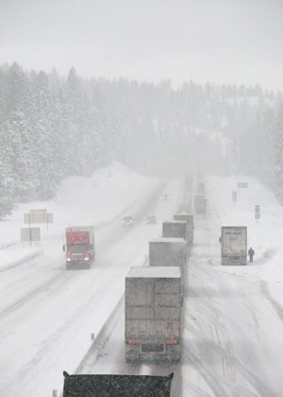
Driving is another task that becomes more hazardous during the winter months. Winter drivers encounter many different hazards, such as snow, ice, and reduced visibility. Road conditions can vary widely. Especially watch out for icy patches on bridges and in shady areas.

Here are a few tips that may help to prevent you or somebody you know from being in a car accident this winter.

- Winterize your vehicle—Check tires (consider snow tires), check your antifreeze, windshield wipers, fluids, batteries, etc.
- Be sure to completely clean off your vehicle of snow before driving it—Don’t forget your head, tail, and warning lights.
- Drive according to the conditions—Stay well below posted speed limits in bad weather and keep a safe distance from the next vehicle.
- Expect the unexpected—Be ready to reduce speed in case of sudden stops. Give yourself plenty of time to reach your destination.
- Keep your lights on—Make sure other drivers can see you.
- Use safe braking techniques to avoid skidding.
- Always gently steer into a skid to regain control of the vehicle.
- Always drive defensively and never while under the influence of drugs or alcohol!

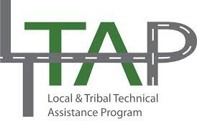

Everyday Safety Tailgate Talks are published by the Cornell Local Roads Program in cooperation with the National Local Technical Assistance Association and participating partner organizations.

Action Item:
Related Topics:
Resources and References:
OSHA Safe Winter Driving Publication
https://www.osha.gov/Publications/SafeDriving.pdf
NTHSA Winter Driving Tips
https://www.nhtsa.gov/winter-driving-tip
National Safety Council Be Prepared For Winter Driving
http://www.nsc.org/learn/safety-knowledge/Pages/news-and-resources-winter-your-car-and- you.aspx

Date: / /

“Cold Weather Driving Safety” Sign In Sheet:

Name: Signature:

