Everyday Safety
Tailgate Talks
Lightning Safety
This Everyday Safety Tailgate Talk was originally published as part of the June 2017 training
series “The Safety Pins” by Phillip E. Spiezio, Washington County Safety Officer

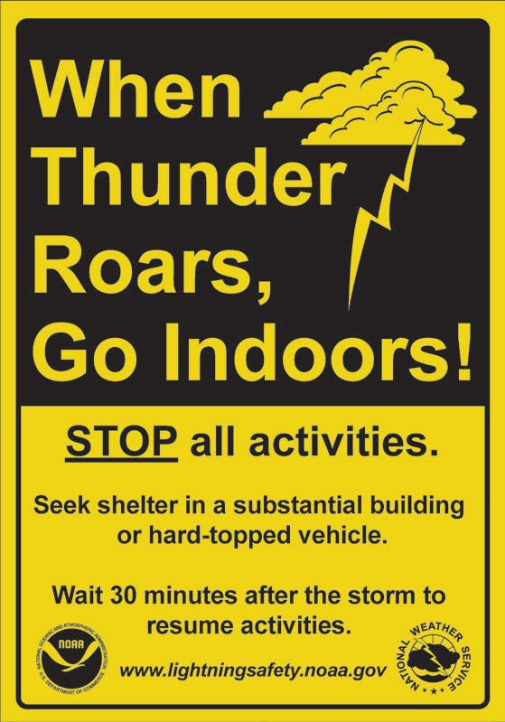
More than 400 people every year are struck by lightning in the United States. On average, 70 of those people struck will die while others will live with life-long, severe disabilities. One interesting fact about lightning strikes worth mentioning – about 90 percent of the deaths are male….

Here are a few tips to help keep you safe the next time a thunderstorm comes through your area:
- All thunderstorms produce lightning, sometimes striking as far away as 10 to 15 miles from any rainfall. This type of lightning is sometimes called ‘Bolts from the Blue’.
- If you can hear thunder then you can be struck by lightning If you hear thunder it is time to go to a safe area!
- If outdoors – Avoid water, high ground, open spaces, and standing under or next to trees or buildings. Stay away from all metal objects such as fences, electric wires or machinery. In other words, seek a substantial structure or a vehicle for your protection. If caught outside with no place to go then as a last resort – Crouch down, put your feet together, tuck your head low and cover your ears. Stay at least 15 feet away from other people or metal objects.
- If indoors – Avoid water, stay away from doors and windows. Do not use a telephone, especially a cord connected one. Unplug and stay away from appliances, computers, and television sets.

Everyday Safety Tailgate Talks are published by the Cornell Local Roads Program in cooperation with the National Local Technical Assistance Association and participating partner organizations.

Action Item:

Related Topics:

Resources and References:
For unbelievable pictures and more information about lightning safety please visit:
www.lightningsafety.noaa.gov

Date: / /

“Lightning Safety” Sign In Sheet:

Name: Signature:

