Everyday Safety
Tailgate Talks
Excavation: Trenching Safety
This Everyday Safety Tailgate Talk was originally published as part of the April 2017 training
series “The Safety Pins” by Phillip E. Spiezio, Washington County Safety Officer

Trench collapses cause dozens of fatalities and hundreds of injuries each year. Here are some guidelines that can help you trench safely on the work site

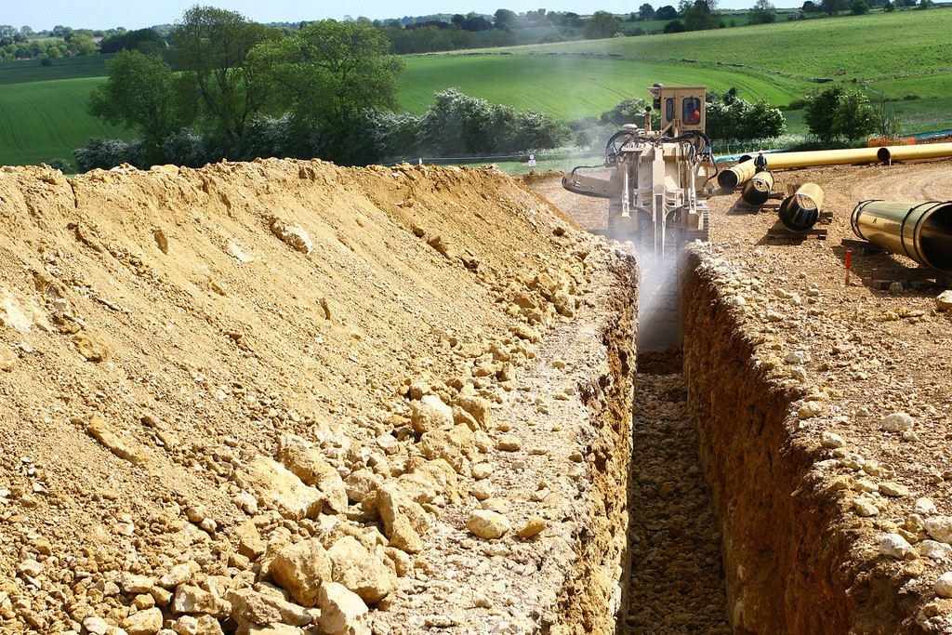
- Trenches 5 feet deep or greater require that a protective system be used.
- Trenches 20 feet deep or greater require that a registered professional engineer design the protective system.
- Keep heavy equipment and excavation spoils at least 2 feet away from the trench edge.
- Provide stairways, ladders, ramps, or other safe means of access & egress in all trenches 4 feet or deeper every 25’. Consider this for shallower trenches as well!

PROTECTIVE SYSTEMS
  - Sloping protects workers by cutting back the trench wall at an angle inclined away from the excavation.
  - Shoring protects workers by installing aluminum, hydraulic or other types of supports to prevent soil movement.
  - Shielding protects workers by using trench boxes or other types of supports to prevent soil cave-ins.
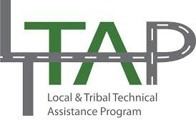

Everyday Safety Tailgate Talks are published by the Cornell Local Roads Program in cooperation with the National Local Technical Assistance Association and participating partner organizations.

COMPETENT PERSON
OSHA standards require that a competent person inspect the trench daily and as conditions change. (An OSHA “competent person” is defined as “one who is capable of identifying existing and predictable hazards in the surroundings or working conditions which are unsanitary, hazardous, or dangerous to employees, and who has authorization to take prompt corrective measures to eliminate them” [29 CFR 1926.32(f)].)

FOUR TYPES OF SOIL: (QUICK OVERVIEW)

Stable Rock
Natural solid material that remains intact

Type A
Not previously disturbed cohesive soil with an unconfined compressive strength greater
than or equal to 1.5 tsf

Type B
Unconfined compressive strength >0.5 tsf <1.5 tsf—angular gravel, silt, silt loam, sandy loam, and, in some cases, silty clay loam and sandy clay loam.

Type C
Unconfined compressive strength <0.5 tsf—Granular soils including gravel, sand, and loamy sand, soil from which water is freely seeping

CONFIGURATIONS
Configurations of sloping and benching systems shall be in accordance with Figure B-1.

Table B-1. Maximum Allowable Slopes

Soil or Rock Type | Maximum Allowable Slopes (H:V)1 for Excavations Less Than 20 Feet Deep3
Stable Rock  Type A 2 Type B Type C | Vertical (90º)  3/4:1 (53º)  1:1 (45º)  1½:1 (34º)
1 Numbers shown in parentheses next to maximum allowable slopes are angles
expressed in degrees from the horizontal. Angles have been rounded off.
2 A short-term maximum allowable slope of 1/2H:1V (63º) is allowed in excavations in Type A soil that are 12 feet (3.67 m) or less in depth. Short-term maximum allowable slopes for excavations greater than 12 feet (3.67 m) in depth shall be 3/4H:1V (53º).
3 Sloping or benching for excavations greater than 20 feet deep shall be designed by a
registered professional engineer.

Action Item:

Related Topics:

Resources and References:
OSHA 29 CFR 1926.32(f)
https://www.osha.gov/pls/oshaweb/owadisp.show_document?p_table=STANDARDS&p_ id=10618
OSHA Trenching and Excavating Webpage URL
https://www.osha.gov/SLTC/trenchingexcavation/index.html
American Pipeline Contractors Association Excavation and Trenching Best Practices http://www.americanpipeline.org/images/safetyzone/BestPractices/English/ ExcavAndTrenching_Operators.pdf

Date: / /

“Trenching Safety” Sign In Sheet:

Name: Signature:

