Everyday Safety
Tailgate Talks
Blood and Bodily Fluid Safety
This Everyday Safety Tailgate Talk was originally published as part of the February 2017
training series “The Safety Pins” by Phillip E. Spiezio, Washington County Safety Officer

BLOODBORNE PATHOGENS AND OTHER BODILY FLUID EXPOSURE OVERVIEW

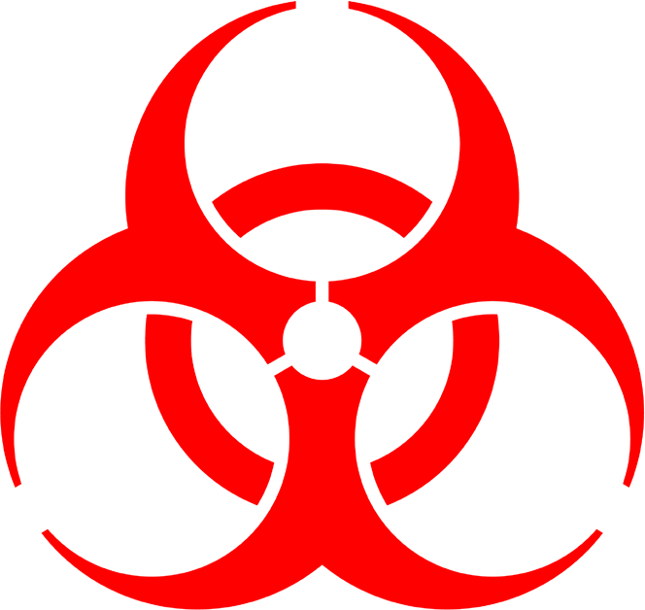
Blood or other bodily fluids may contain infectious organisms that can cause diseases such as Hepatitis B, C, and HIV. If blood or other bodily fluids comes in contact with the eyes, mouth, skin, mucous membranes or through a needle stick immediate action is required. Washing exposed area thoroughly, reporting the incident to your supervisor and seeking medical attention are all required actions.
- Always assume blood is infectious
- Avoid contact with potentially infectious material
- Follow all infection control protocols
- Wear your personal protective equipment—always
- Follow good hygiene—frequently wash hands
- If you must handle a sharp object then use equipment such as forceps
- Report any exposures immediately to your supervisor
- Decontaminate surfaces and materials that have been used to handle, store or temporary place objects that may have come in contact with blood or PIMs. Apply disinfectants (e.g. chlorine bleach solution, Lysol and other EPA-recommended disinfectants) on tools and surfaces. Observe proper precautions when discarding regulated wastes, contaminated sharps and containers.
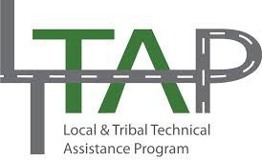

Everyday Safety Tailgate Talks are published by the Cornell Local Roads Program in cooperation with the National Local Technical Assistance Association and participating partner organizations.

Action Item:
According to the 29CFR 1910.1030 or OSHA’s Bloodborne Pathogens Standard, employers should develop an exposure control plan to eliminate or minimize occupational exposure to potentially infectious body fluids.

Related Topics:

Resources and References:
CDC Blood safety webpage URL:
https://www.cdc.gov/bloodsafety/index.html
OSHA Bloodborne Pathogens and Needle Stick Prevention webpage URL
https://www.osha.gov/SLTC/bloodbornepathogens/recognition.html
OSHA 29CFR 1910.1030 Reference Guide
https://www.osha.gov/SLTC/bloodbornepathogens/bloodborne_quickref.html

Date: / /

“Blood and Bodily Fluids Safety” Sign In Sheet:

Name: Signature:

