Everyday Safety
Tailgate Talks

Chainsaw Safety
This This Everyday Safety Tailgate Talk was originally published as the September 2017 “Safety
Pins” by Philip E. Spiezio, Safety Officer, Washington County Office of the Safety Officer

Fire is one of the most common disasters. Fire causes more deaths than any other type of disaster. With early warning from smoke detectors and everyone knowing how to escape from their workplace or home, fires do not have to be so deadly. Here are a few things to consider when planning your escape route:

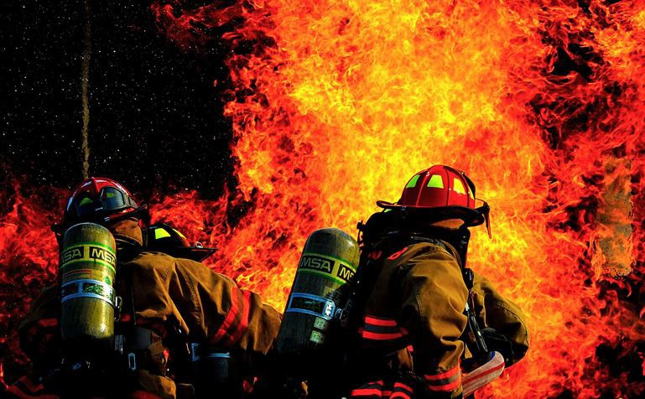
- Determine at least two ways to escape from every room.
- Consider escape ladders for sleeping areas on the second and third floors. Learn how to use and store them near the window.
- Select a location outside your home where everyone will meet.
- Practice your escape plan at least twice a year. Use a blanket to simulate a layer of smoke to teach the kids to stay low. Make it a fun family or work event!
- If you see smoke or fire in your first escape route, use your second way out.
- If you are escaping through a closed door, feel the door before opening it. If it is warm then
use your second way out.
- Keep all exits, exit passageways and stairs clear at all times.
- Once you are out stay out!!!
Remember - fire prevention is your best protection!!!
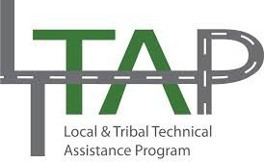

Everyday Safety Tailgate Talks are published by the Cornell Local Roads Program in cooperation with the National Local Technical Assistance Association and participating partner organizations.

Action Item:
Create a fire prevention plan (FPP)
A fire prevention plan must be in writing, be kept in the workplace, and be made available to employees for review. However, an employer with 10 or fewer employees may communicate the plan orally to employees. [29 CFR 1910.39(b)]
At a minimum, your fire prevention plan must include:
- A list of all major fire hazards, proper handling and storage procedures for hazardous materials, potential ignition sources and their control, and the type of fire protection equipment necessary to control each major hazard. [29 CFR 1910.39(c)(1)]
- Procedures to control accumulations of flammable and combustible waste materials. [29 CFR 1910.39(c)(2)]
- Procedures for regular maintenance of safeguards installed on heat-producing equipment
to prevent the accidental ignition of combustible materials. [29 CFR 1910.39(c)(3)]
- The name or job title of employees responsible for maintaining equipment to prevent or control sources of ignition or fires. [29 CFR 1910.39(c)(4)]
- The name or job title of employees responsible for the control of fuel source hazards. [29 CFR 1910.39(c)(5)]
An employer must inform employees upon initial assignment to a job of the fire hazards to which they are exposed. An employer must also review with each employee those parts of the fire prevention plan necessary for self-protection. [29 CFR 1910.39(d)]
Source: https://www.osha.gov/SLTC/etools/evacuation/fire.html

Related Topics:
Hazards of Solvents

Resources and References:
OSHA Fire Safety Standards Website URL
https://www.osha.gov/SLTC/firesafety/standards.html
United State Fire Administration Webpage URL
https://www.usfa.fema.gov/index.html

Date: / /

“Fire Preparedness Safety”
Sign In Sheet:

Name: Signature:

