Everyday Safety
Tailgate Talks
Heavy Equipment Safety
This Everyday Safety Tailgate Talk was originally published as part of the January 2017 training series “Tailgate Talks” by the Connecticut Transportation Institute Technology Transfer Center
Heavy equipment is designed to handle very large volumes or heavy loads. Therefore, these are powerful machines that are dangerous to everyone around them if they are not operated correctly. It is important to remember the proper methods used to move them from one site to another and how to work around their operation.

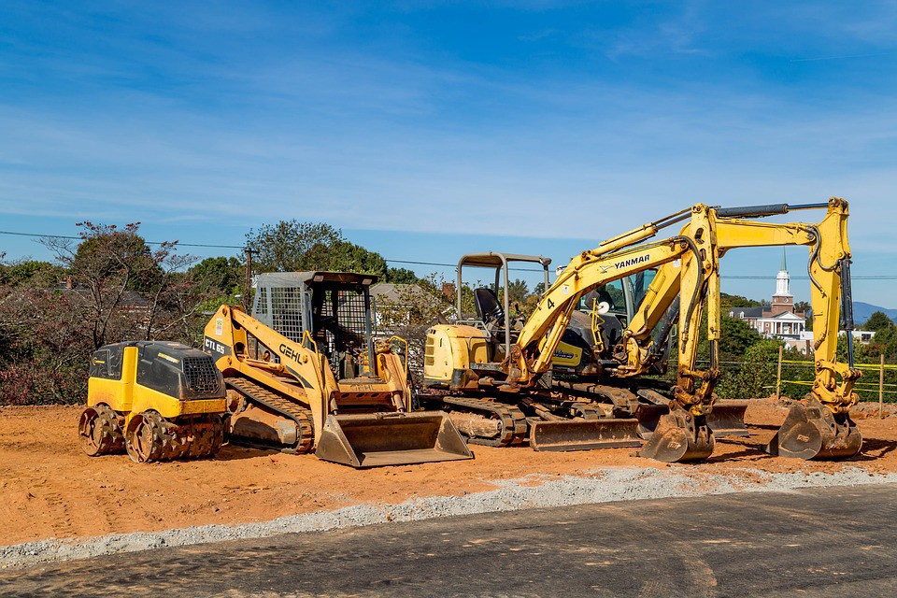
General Rules When Heavy Equipment Is Nearby
- Always remain alert to the equipment moving around you
- Do not get near moving equipment unless necessary.
- Never ride on equipment unless it has been designed to carry you. This means it must have a seat and a seat belt.
- Do not walk along beside equipment. If it is necessary to travel with a piece of equipment, walk in front or behind it.
- Try to stay in view of the operator. You must remain in view of the operator when working in an excavation or trenching if you are the “top man.”

Rules for Transporting Heavy Equipment
- Inspect all transporting equipment and make sure it is all in good working condition
- Always provide for the protection of the general public
- Wear safety shoes.
- Estimate the center of gravity for the equipment to be loaded.
- Always load equipment slowly onto its carrier.
- If equipment is to be driven off-site, make sure the steering, braking, and light systems are
in good operating condition.
- Tightly secure the piece of equipment to its carrier.
- Be sure that the boom or any other extensions of the equipment are tightly secured. If working with others, be sure to work as a team.
- Keep your hands dry and as free of grease and oil as possible.
- Always keep the loading area free of debris and unnecessary tools.
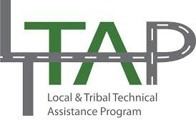

Everyday Safety Tailgate Talks are published by the Cornell Local Roads Program in cooperation with the National Local Technical Assistance Association and participating partner organizations.

Action Item:

For Equipment Operators:
  - Be sure that all moveable equipment is either accompanied by a signal person or has
an operational back-up alarm.
  - Be aware of all overhead power lines and the possible effect on equipment operating
within the close vicinity. Keep crane booms at least 10 feet from all power lines.
  - Always lock out the equipment before it is to be lubricated, adjusted or repaired.
  - Always replace gears, belts, or any other guards after repair or adjustment.
  - Always secure and lock out equipment upon completion of use.
  - Be sure to protect the glass areas of cabs with either metal grates or wood covers.

For Workers:
  - Always be alert to the position of the equipment around you.
  - Only authorized personnel are allowed to operate the equipment.
  - Never ride the equipment unless it is designed for it.
  - Always keep away from suspended loads.
  - When working as a signal person, be aware of all overhead power lines. Keep crane booms at least 10 feet from all power lines.
  - Never take naps, breaks, or lunch around heavy equipment.

Remember: The best policy around heavy equipment is to take no chances. Be aware of what is going on around you—both workers and equipment operators.

Related Topics:

Resources and References:
OSHA 1926.600(a)
https://www.osha.gov/pls/oshaweb/owadisp.show_document?p_table=STANDARDS&p_ id=10767
OSHA Heavy Equipment and Powered Industrial Truck Use Webpage: https://www.osha.gov/pls/oshaweb/owadisp.show_document?p_table=STANDARDS&p_ id=10767

Date: / /

“Heavy Equipment Safety” Sign In Sheet:

Name: Signature:

