VLR SAFETY TAILGATE TALK
Date:

Subject: Burned By Wild Parsnip

Location (garage, mm, etc…):

Instructions:
Safety Coordinators & Supervisors should use this Tailgate Talk as a guide for discussion during their safety meetings. The primary purpose of the safety meetings is to give crews the opportunity to discuss any safety related concerns they may have.
Once the meeting has concluded, the Presenter should have each employee sign this form.
TGT Presenter:

Name 1.
2.

3.

4.

5.

6.

7.

8.

9.

10.

11.

12.

13.

14.

15.

Sun‐induced burns from a common weed stump medical professionals and outdoor enthusiasts alike.
Wild parsnip: The plant that can put you in the hot seat. There are chemicals in wild parsnip called psoralens (precisely, furocoumarins) that cause what dermatologists call “phyto‐photodermatitis”. This means an inflammation (it is) of the skin (derm) induced by a plant (phyto) with the help of sunlight (photo). When absorbed by skin, furocoumarins are energized by ultraviolet light (present during sunny and cloudy day) causing them to bind with nuclear DNA and cell membranes. This process destroys cells and skin tissue, though the reaction takes time to produce visible damage.
In mild cases, affected skin reddens and feels sunburned. In more severe cases, the skin reddens first, then blisters rise — some are impressively large — and for a while the area feels like it has been scalded. Places where skin is most sensitive (arms, legs, torso, face, neck) are most vulnerable. Moisture from perspiration speeds the absorption of the psoralens.
Blisters appear a day or two after sun exposure. Soon after blisters rupture and the skin begins to heal. One of wild parsnip’s “signature” effects is a dark red or brownish discoloration of the skin in the area where the burn occurred. This hyper‐pigmentation can persist in the skin for as long as two years.
Parsnip burns often appear as streaks and long spots. These reveal where a juicy leaf or stem drags across the skin, and is then exposed to the sun. Due to its surface resemblance to the effects of poison ivy, and because wild parsnip is so rarely accurately identified, it nearly always is diagnosed and treated as poison ivy. If you note the six clinical differences (see sidebar), however, you can readily tell them apart.

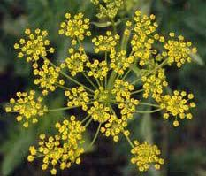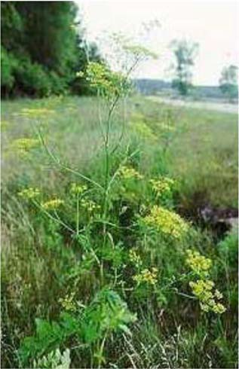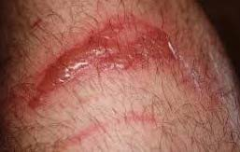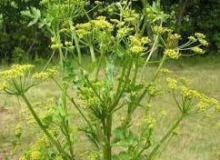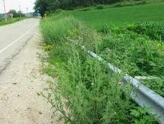Treating a Parsnip Burn:
If you get a parsnip burn, relieving the symptoms comes first. The affected area can be covered with a cool, wet cloth. If blisters are present, try to keep them from rupturing for as long as possible. The skin of a blister is “nature’s bandage” as one doctor put it, and it keeps the skin below protected, moist and clean while healing occurs. When blisters pop, try to leave the skin “bandage” in place. To avoid infection, keep the area clean and apply an antibiotic cream.
Adding Domeboro powder to cool cloth compresses can help dry weeping blisters. Some doctors recommend a topical or systemic cortisone‐steroid for extreme discomfort. For serious cases with extensive blistering, consult a physician.
Avoiding exposure, of course, is the wisest tactic. By learning to recognize the plant in different seasons and in different stages of growth, you can steer clear of it, or protect yourself by wearing gloves, long pants and long‐sleeve shirts. Some people pull up the wild parsnips in the evening, when exposure to sunlight is minimal. If you do get the plant juice on your skin, the sooner you thoroughly wash the area, the less you will be affected.

Special thanks to David J. Eagan for this article.

