 | Information You Can Use to Prevent Accidents & Injuries
Tree & Brush Trimming Safety | When cutting out brush and tree branches which have created sight and clearance problems, there are several hazards to deal with. They include moving traffic, hidden objects, unstable footing, poison ivy and oak, thorns, tools with sharp edges, chain saws, chippers, and difficult access to the work area.  If they are going to be used, review the safe operating procedures for chippers, chain saws, and stump grinders. Personal protective equipment is necessary when using chippers and chain saws on the work site including gloves, goggles, face shield, chaps, hard hat, and hearing protection. Hard hats are available for tree trimming crews which have both the face shield and hearing protection/ear muffs attached. Keep shirt sleeves rolled down and use barrier creams to control exposure to poison ivy and oak.  Always attempt to park vehicles and equipment in an area that's suitable for safe entering and exiting the work site. Park so that there are no hazards in the way of workers who must relay materials to a truck and/or chipper. Allow enough space for each employee to work safely. Injuries have been reported when workers have been struck by tools, falling branches, and tree trunks.  Let everyone know when you're about to cut off a large branch or tree trunk. Safety when cutting brush or trees has a lot to do with simply warning your fellow workers when something is about to happen that may hurt them!  Two persons should work as a team to cut down a tree. Check to see the direction of its lean, the direction of the wind, how close it is to other trees, nearby buildings, fences, and wires. Make sure you have a path of safe retreat before you cut down the tree so when it starts over, all you have to do is shut off the saw and move to a safe place, well out of the way.  While one person cuts, the other should look for any movement and warn the saw operator if the tree begins to rock. A pull rope of good size should be used whenever possible to eliminate the use of wedges. This will enable the saw to be removed quickly.  <Continued on Page 2>

Page 2

Always leave enough wood on the felling cut to hinge the tree in the fall direction. If there is any possibility that the tree might go in the wrong direction or rock back and bind the saw, stop cutting and use a wedge to open up the cut and tilt the tree in the direction of the fall.

If you use a hand saw, make sure it is sharp. Otherwise it will tend to grab and create a hazard. Keep it at right angles to the work surface. The piece to be cut must be held firmly. Keep fingers clear of the work area and use slow easy strokes, remembering that the saw cuts only on the forward stroke. A little oil on both sides of the saw will make the work easier.

Keep tree pruners sharp at all times. Don't try to cut too large of a branch with hand pruners; usually nothing larger than one inch in diameter. Cutting branches too large for the pruners will cause a strain on the tool and may also cause you to strain a muscle trying to force the tool to do a job that it's not designed for. Get a firm footing and don't attempt to prune something from an awkward position.

When using a chipper, always feed limbs and brush butt end first. Don't attempt to hold onto brush and limbs after they start to feed and turn away from the machine to avoid injuries from whipping material. Don't force materials or attempt to hand feed small pieces. If it doesn't feed, push it with another limb. Wear gloves with tight fitting cuffs, such as mechanics gloves. Avoid wearing gauntlet style gloves. A branch can get caught in the loose cuff and pull you toward the chipper.
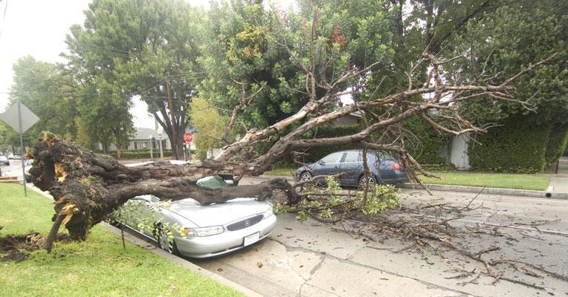

Users of this tailgate talk are advised to determine the suitability of the information as it applies to local situations and work practices and its conformance with applicable laws and regulations.

