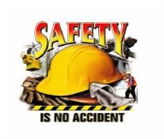
Driving Safely in Traffic

Information You Can Use to Prevent Accidents & Injuries

When you are driving in traffic, what are some things you must do to avoid accidents? Avoiding accidents in traffic is a little different than avoiding accidents on the open road. Long-distance drivers know that fatigue is responsible for numerous accidents. But what causes accidents when you are driving around town, making frequent stops? This tailgate safety talk discusses some of the causes of these accidents and what you can do to prevent them.
Many people spend a lot of time on the road as they are working. On any city street you are likely to see delivery vans, couriers, salespeople, and utility persons making frequent stops as they conduct their business. Some people spend many hours in traffic just going to and from work. Even though the mileage may be small, the amount of time spent on the road is very long. Every hour spent on the road increases your chance of having an accident.
Certainly, speed is a factor in accidents. Many accidents happen simply because the driver is going too fast. City streets usually have speed limits of less than 25 miles per hour, and often you will see posted limits as low as 5 or 10 miles per hour. Speed limits are carefully selected to minimize the chances of accidents.
When traffic is heavy, there just isn't very much distance between you and the next vehicle to stop. The slower you are going, the less distance it will take to stop. By going slowly, you will also be able to observe your surroundings more easily, taking note of cyclists, pedestrians, and other vehicles. Observing the speed limit is one sure way to reduce your chance of an accident. On rainy, foggy, or snowy days keep your speed even lower.
When you make stops, park your vehicle carefully. Avoid leaving it in a space that's likely to block traffic or create a blind spot. As you exit the vehicle look both ways before stepping into the road or onto the sidewalk. You'll want to avoid collisions with other vehicles as well as bicycles and pedestrians.
If you must load things into or out of your vehicle, be sure your load does not obstruct your vision. It is better to make several trips with smaller loads than to overload yourself to the point you cannot see other vehicles. It will also help prevent tripping and falling over objects in your path.

Perhaps the main cause of accidents in traffic is a simple matter of not paying attention. In traffic, it is easy to become distracted, frustrated, or annoyed. Any of these can cause you to pay less attention than you should, often resulting in rear-end collisions when the vehicle in front of you stops. Running stop lights and stop signs is also a possibility if you are not paying attention.

Sometimes paying attention to the wrong things can cause accidents, too. Reading addresses on buildings, street signs, and maps while driving can lead to accidents.

You will be better off if you find a place to pull over safely while you read signs and addresses. Even better, try to pinpoint the exact location when you plan your trip-before you begin driving.

Fatigue is also a contributor to traffic accidents. After a long day's work, or perhaps a morning when you did not rest well the night before, you are likely to feel tired. Feeling tired causes, you to become distracted easily and slows your reflexes.

Do not take chances driving when you feel too tired to be safe. If fatigue is a frequent problem, see your doctor. For occasional fatigue, combat it with adequate rest, nutrition, and exercise.

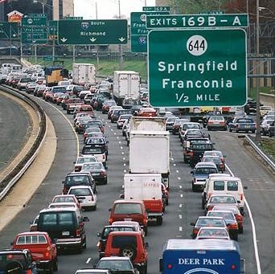
To drive safely in traffic, you must keep your speed down, pay attention, and avoid driving when you are tired. Many accidents and injuries could be prevented by following these precautions. Next time you are in traffic, remember these things and keep yourself safe!

Users of this tailgate talk are advised to determine the suitability of the information as it applies to local situations and work practices and its conformance with applicable laws and regulations.

