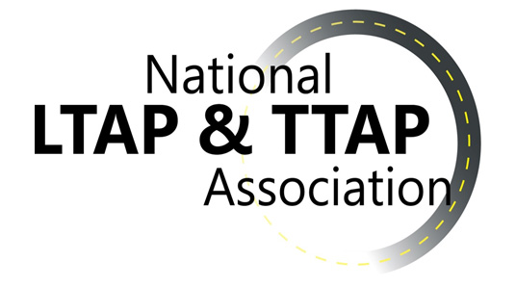
By NOMINATION INFORMATION
2020 NATIONAL PROGRAM ACHIEVEMENT AWARD

The National Program Achievement Award is presented by NLTAPA to an individual (or individuals) in recognition of their dedication, leadership, and effectiveness in promoting the goals and purposes of the National Local and Tribal Technical Assistance Program through service to the Association (NLTAPA).

Eligibility:
Any current or former employee of an LTAP or TTAP center, an FHWA program office, or a partner organization (broadly defined).

Selection Criteria:
Significance and robustness of the impact of the nominee’s accomplishments on the future of the national LTAP/TTAP program, with consideration for the type and duration of the services performed at the national level.

Leadership quality, particularly demonstrated ability to communicate and work collaboratively with constituencies beyond the local level.

Dedication and effort, going beyond expectation and beyond the regular job description.

Selection Process:
Selection of the recipient(s) is made by vote of the three NLTAPA Executive Committee Officers (President, President-Elect, and Vice-President) the NLTAPA Secretary, and a representative from the Professional Development Workgroup. In the event one of these individuals is nominated for this award, the individual would be removed from the voting process and the EC Officers would select an alternate voter.

The award will be presented to the recipient(s) at the annual summer NLTAPA Conference.

Submitting a Nomination:
Please email the completed nomination form (see next page) with any supporting attachments to the NLTAPA Secretary, Tracy Coan. tracy.coan@csus.edu

Nominations must be received by Friday, August 21, 2020. This is a strict deadline.
NOMINATION FORM
2020 NATIONAL PROGRAM ACHIEVEMENT AWARD

Directions: Please enter responses below and on the following page. Answers may be short, but should include examples whenever possible; attach additional information as necessary.

Submit the completed form by Friday, August 21, 2020 to the NLTAPA Secretary, Tracy Coan. tracy.coan@csus.edu

1. Nominee’s name:

2. Nominee’s position/organization:

3. Nominee’s contact information:
Email
Phone
Mailing address

4. Describe the nominee’s history with LTAP/TTAP (e.g., positions held at local and national levels, or you may attach a resume)

5. How has the nominee demonstrated leadership quality?

6. How has the nominee exceeded expectation in dedication and effort for LTAP/TTAP?

7. Describe the nominee’s most significant achievement(s), including the potential of these achievements to have long lasting impact on the future of the national program.

8. Your contact information:
Name
Position/Organization
Email
Phone

9. Name, email, phone for others who support this nomination:

National Program Achievement Award Recipients
Year Awarded | Recipient | Recipient’s Agency
1999 | Ray Griffith | FHWA
2000 | Nelson Evans | Texas LTAP
2001 | Anna Bennet | California LTAP
2002 | George Shrieves | FHWA
2003 | Bill Bowmaster | Nebraska LTAP
2004 | Janet Coleman | FHWA
2005 | --- | ---
2006 | Cherri Marti  Maria Ardila-Coulson  Hank Lambert | Minnesota LTAP  Nevada LTAP  Vermont LTAP
2007 | Patsy Anderson | Kentucky LTAP
2008 | Roger Dean  Terry McNinch | FHWA  Michigan LTAP
2009 | Gene Wilson  Lisa Harris | Wyoming LTAP (ret)  Kansas LTAP
2010 | Marie Walsh | Louisiana LTAP
2011 | Laura Melendy | California LTAP
2012 | Tony Giancola | NACE
2013 | Clark Martin | FHWA
2014 | Janet Leli  Jim Grothaus | New Jersey LTAP  Minnesota LTAP
2015 | Ken Skorseth  Cameron Ishaq | South Dakota LTAP  FHWA Contractor
2016 | Ron Eck | West Virginia LTAP
2017 | --- | ---
2018 | Victoria Beale  Jeff Zaharewicz | Ohio LTAP  FHWA
2019 | David Orr  Renee Cusson Railsback | Cornell Local Roads (NY LTAP)  Colorado LTAP

